Example Abstract for the 2004 International Interdisciplinary Workshop on MR flow and Motion

Roger Luechinger¹, Sebastian Kozerke¹, Paul Summers²

¹Institute for Biomedical Engineering, University and ETH Zurich,

²Institute for Neuroradiology, University Hospital Zurich
abstracts-flowmotion04@www.mr.ethz.ch

Introduction:
The closing date for Workshop abstract submission is: 23. April 2004. The opportunity to present current work in the relevant fields of MR and computational fluid dynamics is open to active researchers whether students, post-doctoral or faculty members. Preference will be given to research work which is current and in the opinion of the program committee demonstrates novel, challenging or influential insights into or applications of the techniques.
The number of accepted abstracts will be limited to ensure adequate time for presentation and discussion. If you would prefer a poster presentation, please select the option on the abstract-submission form.

Methods:
Submitted abstracts should fit the following guidelines:
Length: Maximum of 2 pages
Paper size: DIN A4 Size (210 mm x 297 mm).
Rand: Leave a 25mm margin at top and bottom of the page, and a 20mm margin at left and right sides. Page-Layout: Set the text in two columns of 80 mm width, with a central separation of 10mm.
Font properties and size: Title: 14 pt, bold; Authors: 14 pt, normal; Institute + E-mail address: 12 pt, italics; Section headings: 10 pt, Capitals, bold; Text: 10 pt, normal
Recommended section titles for abstracts: INTRODUCTION, THEORY, MATERIALS AND METHODS, RESULTS DISCUSSION REFERENCES, Language: English

Results:
The abstracts will be reproduced in printed form as part of the conference materials provided to conference attendees. All figures will be printed in grayscale.
Completed abstracts should be submitted as a pdf-file via the online submission at:
http://www.mr.ethz.ch/flomotion04/form/form_abstract.html

Discussion:
Please contact the following e-mail address with any questions:
flow-motion2004@www.mr.ethz.ch
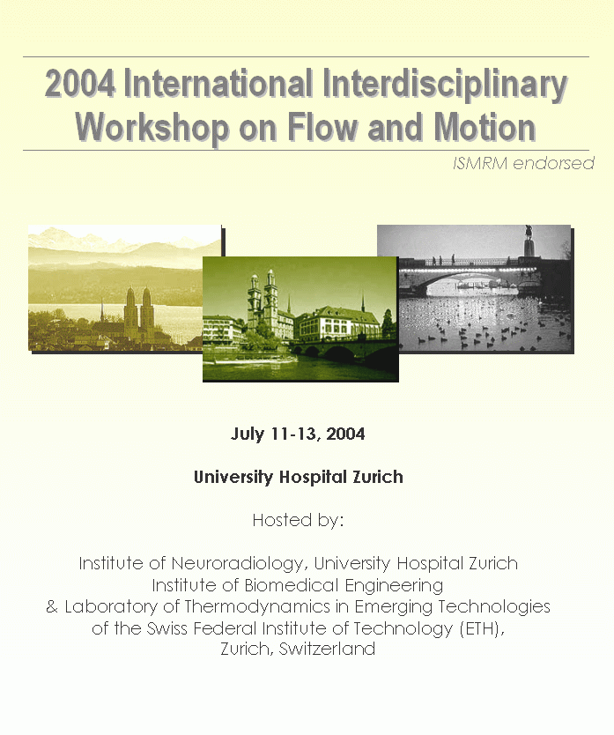
Figure 1: Please ensure that the important features of any color figures can be acceptably reproduced with a black and white printer.
See you in Zurich

The Organizing Committee

References:
[1] H. Muster et.al., ISMRM 2001, S.1000

